The Farmax ERP is a spader for light tractors. The great manoeuvrability and low integral weight of the ERP make it highly suitable for use in greenhouse horticulture, fl ower cultivation and tilling small plots.
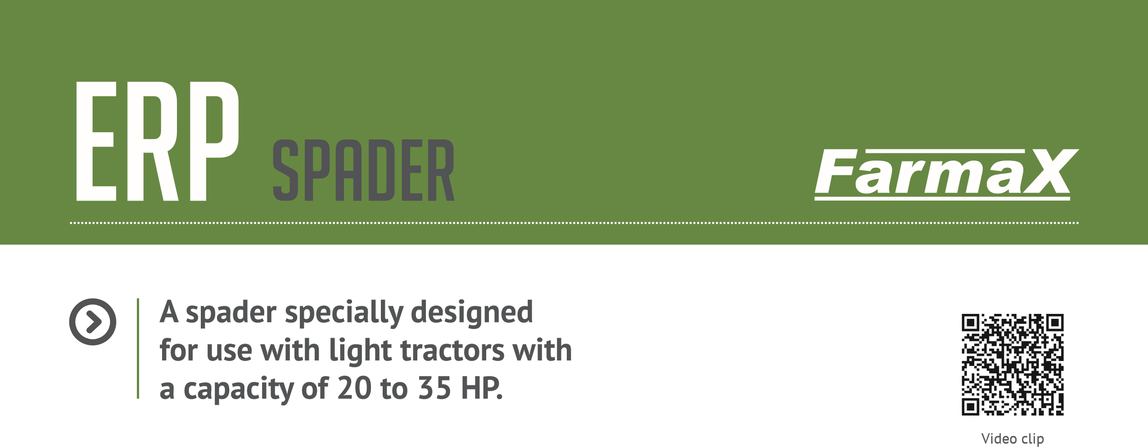
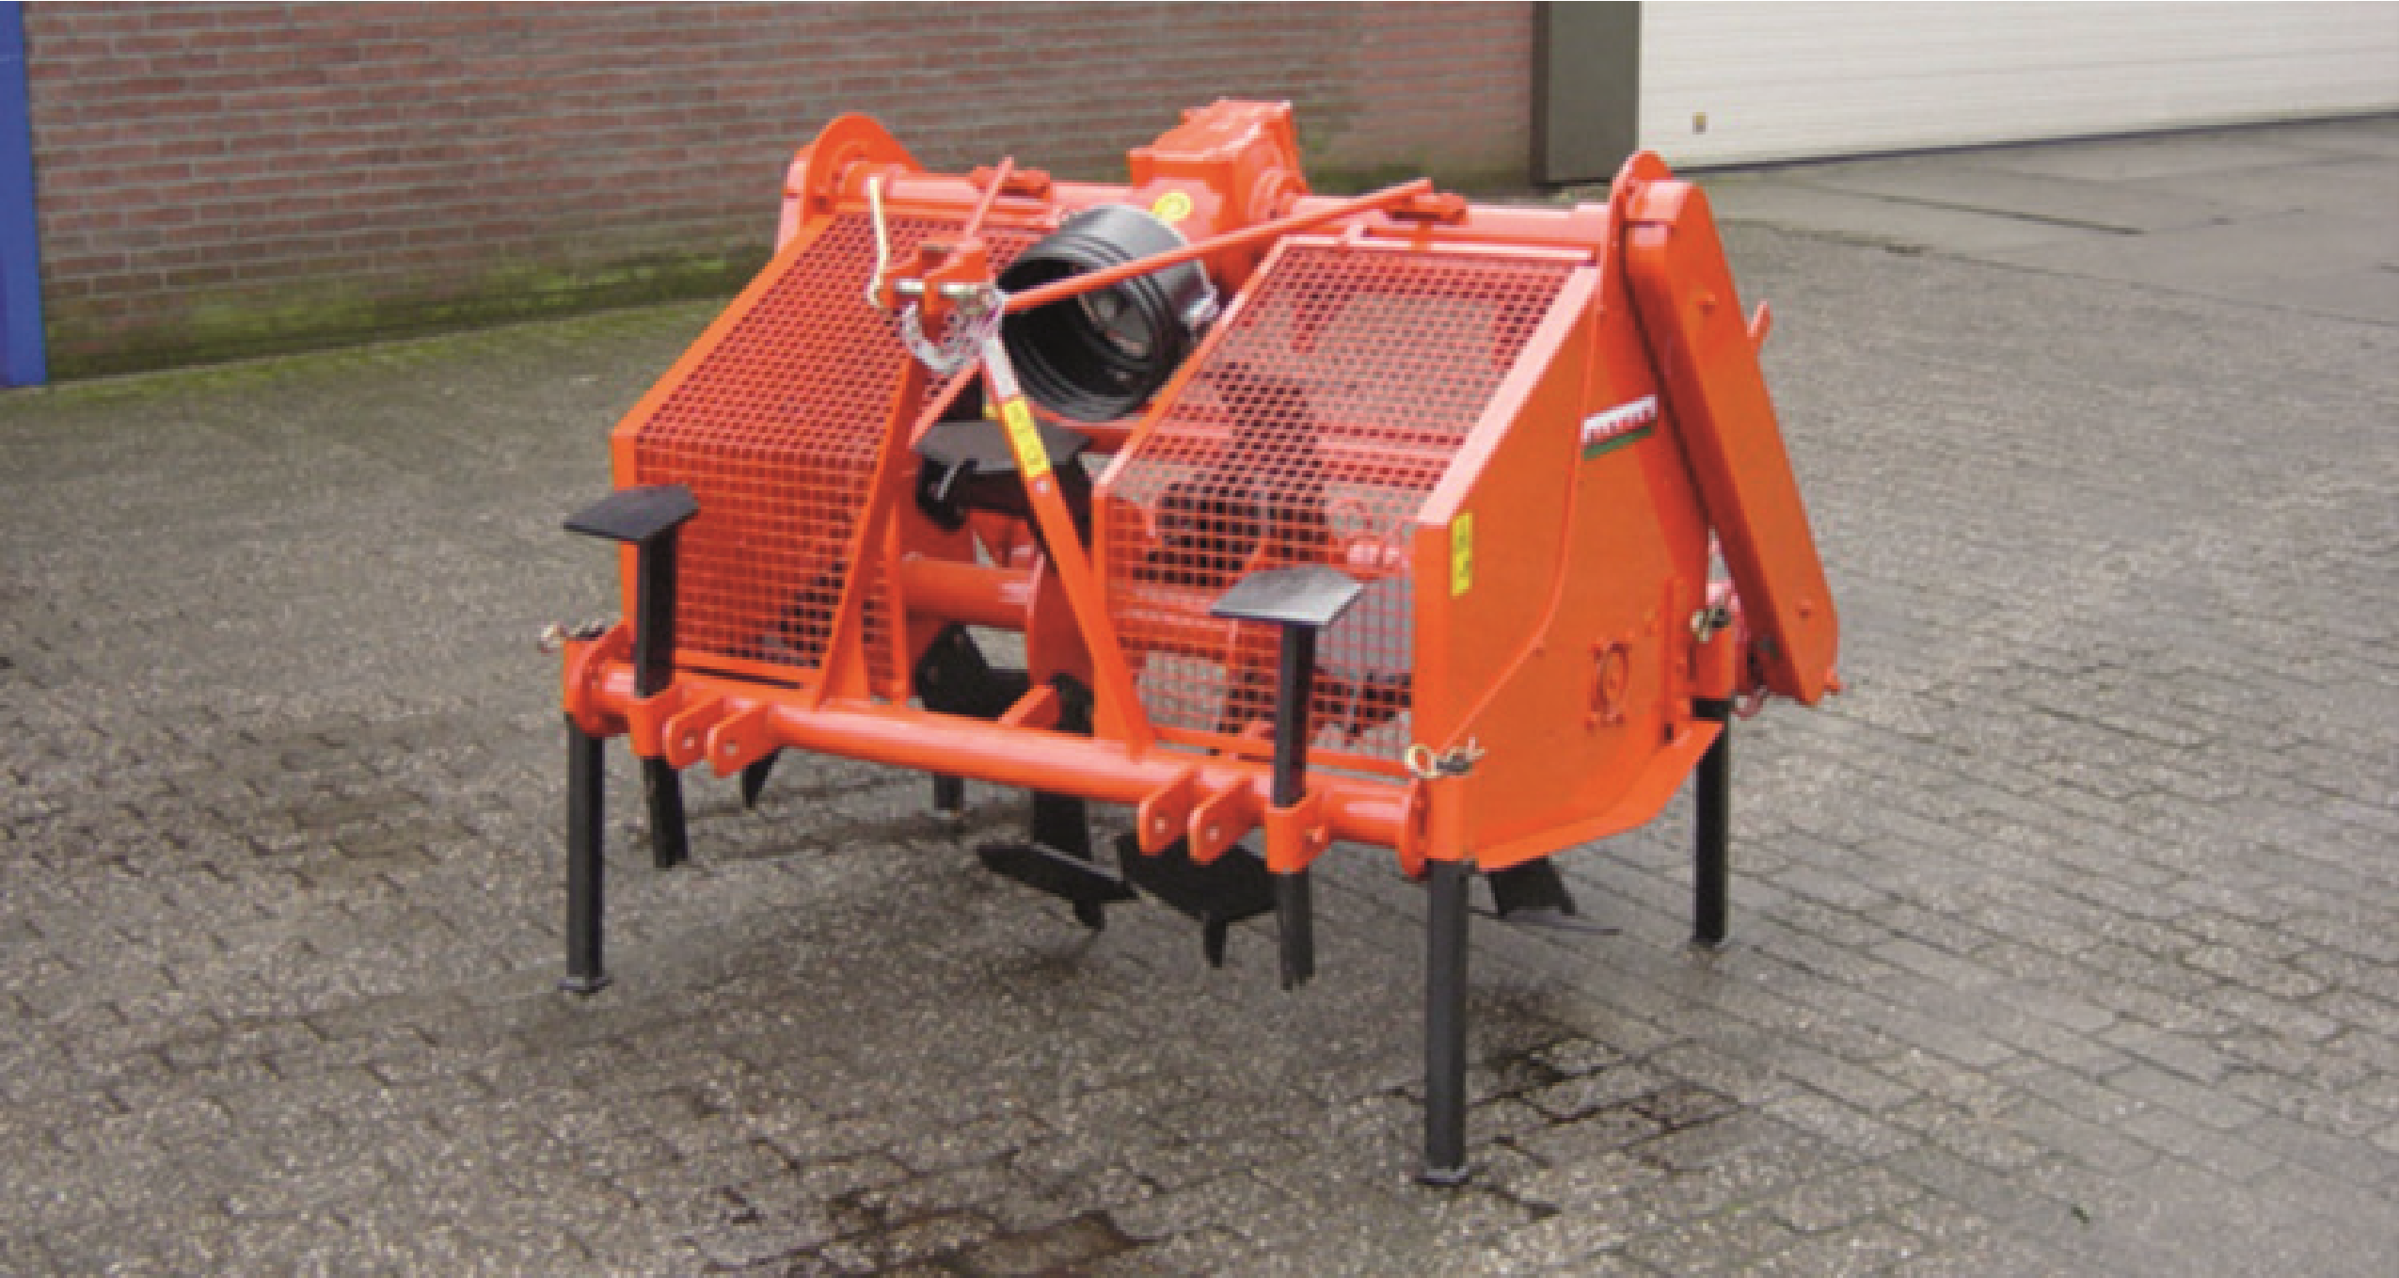
Apart from giving perfect rotavation, the popularity of the Farmax ERP is mainly attributable to its ease of operation and sturdy design.
www.farmax.info
Wasse BV | Oranjekanaal Zuidzijde 17 | 9415 PR Hijken | Netherlands | Tel: +31 (0)593 524 066 | www.wasse.nl | info@wasse.nl

Uninterrupted rotavation
The ERP is fi tted as standard with skimmers to prevent the tilled soil from clogging the machine. The machine can be combined with a rotary harrow.
ERP spader
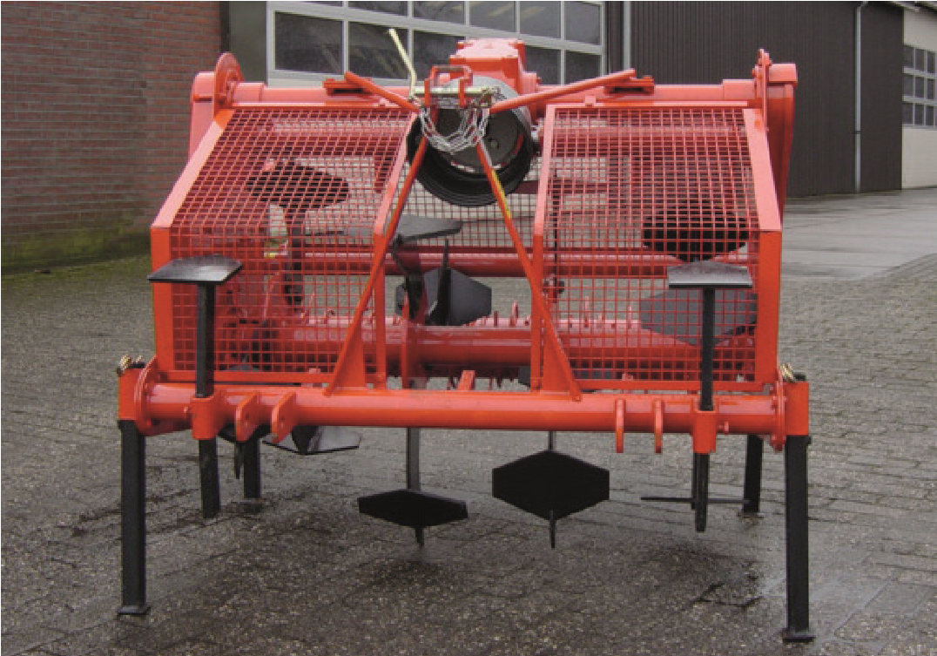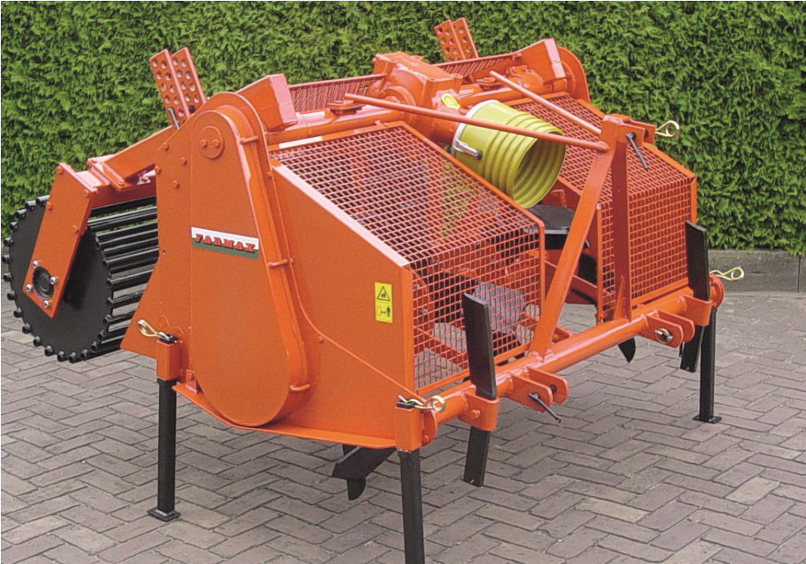
Drive: Single-sided chain transmission
Tractor power: 20 to 35 HP Power take-off revs: 540 r.p.m.

Advantages
- low power requirement, so suitable for small tractors
www.farmax.info
Wasse BV | Oranjekanaal Zuidzijde 17 | 9415 PR Hijken | Netherlands | Tel: +31 (0)593 524 066 | www.wasse.nl | info@wasse.nl
- highly manoeuvrable, even in small spaces
- easy to operate
- sturdy, low-maintenance design
- improved yield thanks to improved soil structure

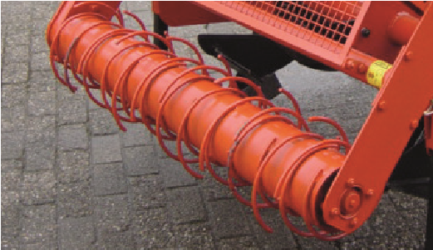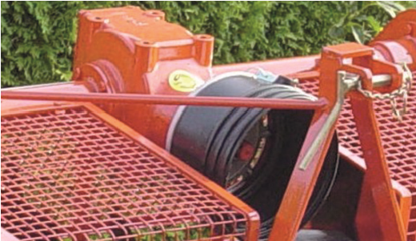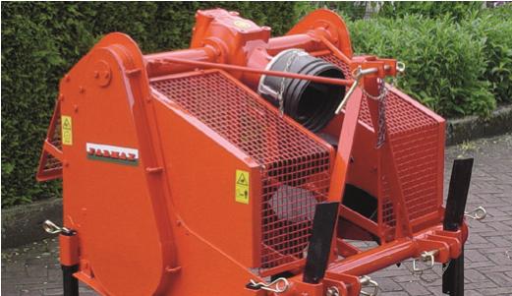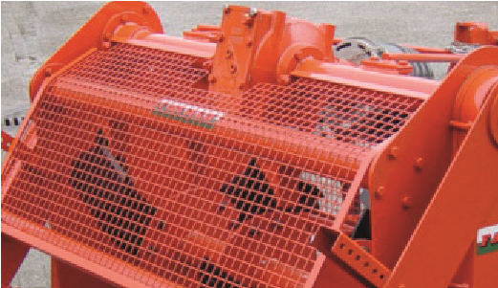
Also available without rotary harrow
Rotary harrow ensures an
optimum bed for sowing
With light transmission case
Mechanical adjustment of
the rotary harrow

Technical Data
type | operating width | max.  operating depth | standard  weight | required power kW/HP | number  of spades
ERP 90 | 35.43” - 90 cm | 17.72” - 45 cm | 573 Lbs - 260 kg | 13/18 | 12
ERP 105 | 41.34” - 105 cm | 17.72” - 45 cm | 650 Lbs - 295 kg | 15/20 | 12
ERP 125 | 49.21” - 125 cm | 17.72” - 45 cm | 760 Lbs - 345 kg | 16/21 | 12
ERP 140 | 55.12” - 140 cm | 17.72” - 45 cm | 870 Lbs - 395 kg | 21/28 | 12
ERP 155 | 61.02” - 155 cm | 17.72” - 45 cm | 992 Lbs - 450 kg | 22/30 | 12

